## VISVESVARAYA TECHNOLOGICAL UNIVERSITY

## 

**“Jnana Sangama”,** Belagavi-590018, Karnataka

**DEPARTMENT OF ELECTRONICS & TELECOMMUNICATION ENGINEERING**

**BANGALORE INSTITUTE OF TECHNOLOGY**

K.R. Road, V.V. Pura, Bengaluru-560 004



**MATH-4254**

**BY**

**SYED MAAZ (1BI22ET054)**

**SAMITH R (1BI22ET042)**

**VINEETH KRISHNA(1BI22ET012)**

**S NANDAN(1BI22EC128)**

**OBJECTIVE**

This project was chosen with the primary objective of learning, understanding and enhancing our skills and knowledge through learning-based approach.

The other objective of this project is to design, develop, and implement a versatile and remotely operated vehicle capable of navigating and gathering crucial information from location that are difficult to access by conventional means

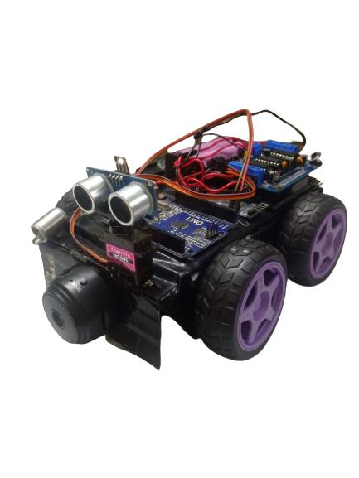

**INTRODUCTION**

**MATH-4254**

In the ever-evolving landscape of transportation, the fusion of human ingenuity and cutting-edge technology continues to redefine what's possible. Imagine a compact-sized vehicle that seamlessly integrates the precision of Arduino technology with sophisticated sensing capabilities, empowering both human control and automated functionalities. This groundbreaking innovation represents a pivotal leap forward in the realm of mobility, offering unparalleled versatility, safety, and efficiency.

At the heart of this revolutionary vehicle lies Arduino, a versatile microcontroller platform renowned for its flexibility and adaptability. Leveraging the power of Arduino, this compact vehicle transcends traditional boundaries, offering a platform that can be customized and programmed to meet diverse needs and preferences. Whether it's navigating through crowded urban streets or traversing rugged terrain, the Arduino-powered vehicle provides a robust foundation for limitless innovation.

Central to the functionality of this vehicle is its advanced sensing capabilities. Equipped with state-of-the-art cameras, this intelligent vehicle possesses a keen visual perception, enabling it to detect obstacles, and navigate complex environments with unparalleled precision. Additionally, integrated radar technology further enhances situational awareness, offering a comprehensive view of the vehicle's surroundings and enabling proactive collision avoidance strategies.

However, what truly sets this vehicle apart is its seamless integration of human control and automated functionalities. Designed to augment rather than replace the driver, this hybrid approach combines the intuition and decision-making abilities of humans with the precision and consistency of automated systems. Through intuitive interfaces and ergonomic controls, drivers can effortlessly switch between manual and autonomous modes, providing the ultimate flexibility and control over their driving experience.

In essence, the human-controlled Arduino-built vehicle with advanced sensing capabilities represents a convergence of innovation and practicality. By harnessing the power of technology to enhance safety, efficiency, and convenience, this remarkable vehicle heralds a new era where the boundaries between human and machine blur, and the possibilities are limitless**.**

**DESGIN AND FUNCTIONALITIES**

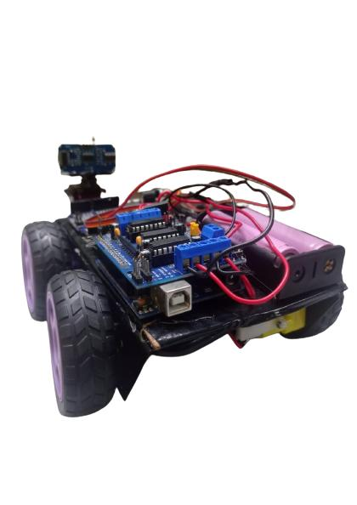

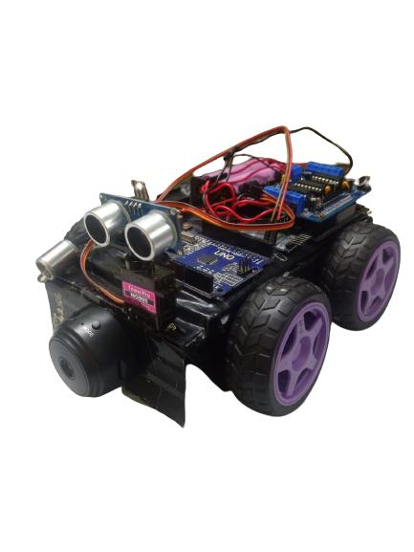

VISUAL SENSOR

LIGHT EMITTING DIODE

MOTOR DRIVE L293D

SERVO MOTOR

ULTRASONIC SENSOR

ARDUINO UNO

SWITCH

BLUETOOTH MODULE

COORDINATES TRANSMITTER

GEAR MOTOR

WHEEL

BATTERIES

**CIRCUIT**

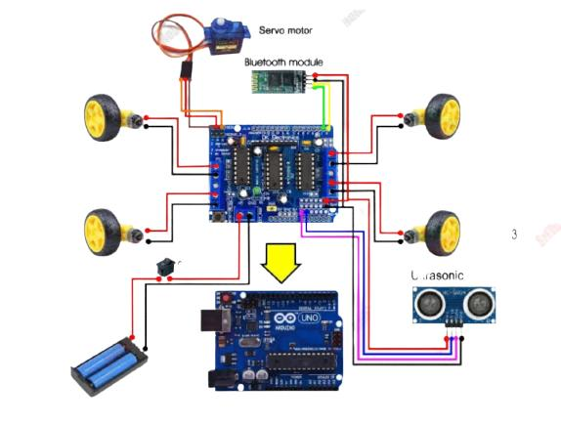

1. Driving circuit

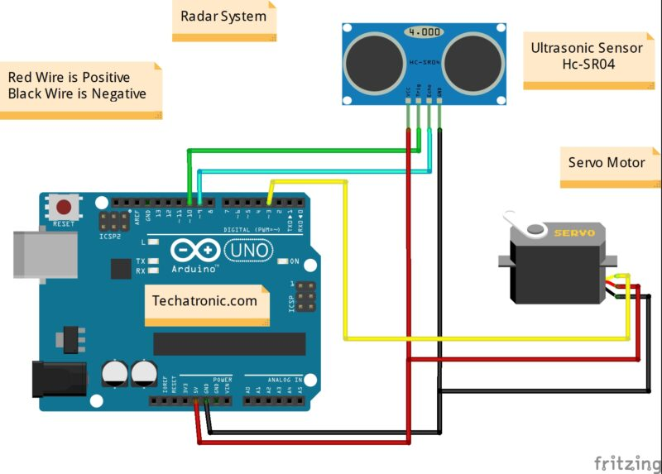

1. Object detector

**AREA OF FENCTIONALITIES**

**.MILITARY PURPOSES:**

military personnel to gather intelligence, conduct surveillance, and carry out reconnaissance missions without drawing undue attention from adversaries.

These vehicles are typically lightweight and agile, allowing them to navigate through tight spaces, urban areas, and rough terrains with ease.

Small vehicles with cameras can be remotely controlled, reducing the risk to human personnel in dangerous situations. Operators can monitor and control these vehicles from a safe distance, minimizing potential harm and casualties.

Small vehicles with cameras can be remotely controlled, reducing the risk to human personnel in dangerous situations. Operators can monitor and control these vehicles from a safe distance, minimizing potential harm and casualties.

The high-resolution imagery captured by cameras can provide actionable intelligence that informs military strategies. This includes identifying potential targets, evaluating the effectiveness of previous operations.

Radars can detect ground-based movements, such as enemy troop movements, vehicles, and artillery positions. This information aids in strategic planning and battlefield

**INTERSTELLAR MISSIONS:**

Manual control allows scientists and operators on Earth to make immediate decisions based on the data being received from the vehicle's cameras.

Human operators can steer the vehicle towards interesting features or locations, making it possible to investigate.

With manual control, operators can precisely guide the vehicle to collect specific samples of rocks, soil, or other materials of interest.

Human operators can direct the cameras to capture detailed images of specific features from different angles and perspectives, providing a more comprehensive view of the environment and enhancing our understanding of the planet's surface.

Manual control vehicles facilitate an adaptive research approach, allowing scientists to change their focus or priorities based on on-the-fly observations, enhancing the efficiency of data collection.

**CONCLUSION**

The development of a manually controlled vehicle for planetary exploration represents a significant leap forward in our ability to understand and unravel the mysteries of distant worlds. By merging human expertise with real-time decision-making, this project opens doors to unforeseen discoveries, targeted sample collection, and adaptable research strategies.

In conclusion, our journey with the manually controlled vehicle project has been an enlightening and transformative experience with a lots of up and downs.